Final Exam CSS Page

Kartik Velede

8672807

Branding - Style Guides – INFO8920

Joseph Olubobokun

August – 21 – 2020

August – 21– 2020

1. Before applying the CSS code styling to the page

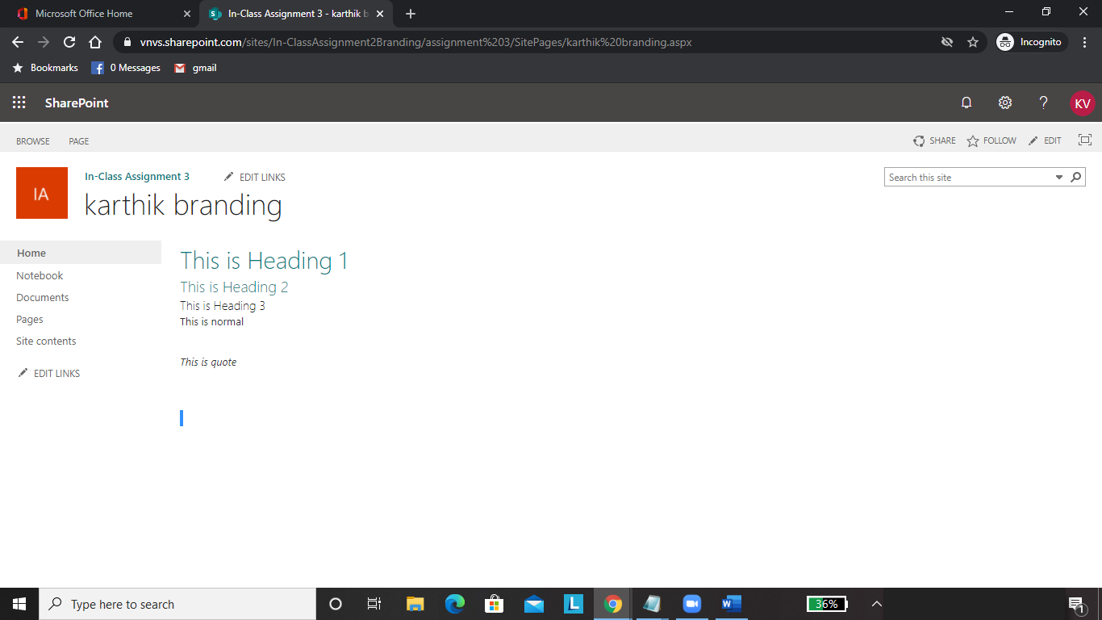

1. After applying the CSS code styling to page

